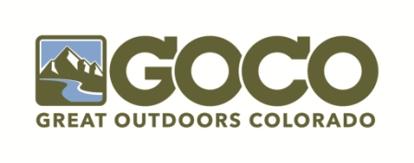
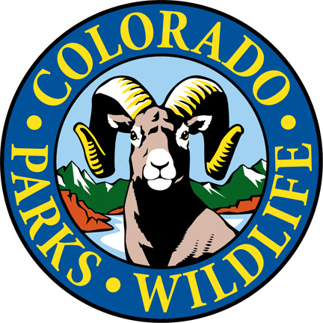

2020 CPW Director’s Innovation Fund GOCO Grant Application

Great Outdoors Colorado (GOCO) is pleased to announce the final round of the CPW Director’s Innovation Fund under GOCO’s 2015 Strategic Plan. The Director’s Innovation Fund, created collaboratively between Colorado Parks and Wildlife (CPW) and GOCO, is designed to highlight and elevate unique, one-time projects that complement CPW’s and GOCO’s respective missions. Requests up to $25,000 will be considered and reviewed jointly by GOCO and CPW staff. The CPW Director will have final approval before projects are presented to the GOCO Board for funding approval.
The Director’s Innovation Fund is open to all CPW staff for parks or wildlife purpose projects. Requests that embody one or more of the following values will compete better:
- Equitable Access
We value and support partners and communities actively breaking down barriers to the outdoors.
- Community Vitality
We help partners leverage conservation and outdoor recreation to improve their communities and peoples’ quality of life – to create jobs and promote economic activity, support public health, and enhance education.
- Resource Conservation
We support strategic land conservation and resource protection outcomes.
- Outdoor Stewardship
We invest in projects that sustain and improve the state’s natural and recreational resources.
- Youth Connections
We believe children deserve the opportunity to get outside, benefitting from the happiness, health, and sense of community that come with positive outdoor experiences.

ABOUT US: GOCO invests a portion of Colorado Lottery proceeds to help preserve and enhance the state's parks, trails, wildlife, rivers, and open spaces. Our independent board awards competitive grants to local governments and land trusts and makes investments through Colorado Parks and Wildlife. Created by voters in 1992, GOCO has committed more than $1.2 billion in lottery proceeds to more than 5,200 projects in all 64 counties without any tax dollar support. For more information, please visit www.GOCO.org.

General Guidance and Grant Information
IMPORTANT DATES: Applications must be submitted to GOCO no later than 5:00 p.m., April 3, 2020. Grants must be submitted via email to GOCO’s Parks and Wildlife Program Manager, Emily Orbanek at eorbanek@goco.org. Grant awards will be made on June 11, 2020. Draft applications may be submitted for pre-review by GOCO until March 13, 2020 (draft applications are not required).
ELIGIBILITY: The Director’s Innovation Fund is open to all CPW staff for parks or wildlife purpose projects. The Innovation Fund is intended for creative, one-time projects that are not funded annually through GOCO or other sources. Additionally, funding cannot be substituted or redirected for previously allocated funds. Projects involving trails, restoration, education and other GOCO funded program areas will be held to a higher standard in the review process. Applicants are welcome to discuss projects with GOCO staff at any point during the application period. If you plan to request more than $25,000, you must discuss your project with GOCO prior to submitting.
PROJECT SCOPE: Projects may involve, but are not limited to, the following program areas: stewardship; education; hunting, fishing, and other outdoor recreation activities; planning and community engagement; innovative programming; and small construction that has not been submitted through internal CPW processes.
MATCH REQUIREMENTS: The CPW Director’s Innovation Fund requires a minimum match of 15% of total project cost. Eligible match can include: staff time; volunteer time; in-kind donations; or other CPW funds. GOCO will not fund more than 85% of the total project cost.
SCORING: Applications will be reviewed and scored jointly by GOCO and CPW staff. The CPW Director will have final approval of the applications before they are presented to the GOCO Board for funding awards.
TIMELINE FOR COMPLETION AND REPORTING: As defined in the GOCO and CPW Memorandum of Agreement, funds must be expended within three years of the award month, June 30, 2023.
The primary project applicant must provide a grant report, once the project is finalized, that provides a sufficient and detailed evaluation of the project.
REIMBURSEMENT GRANTS: Like CPW’s annual investment dollars from GOCO, awards will be disbursed on a reimbursement basis. GOCO and CPW staff will work together to set up appropriate billing codes after awards have been made by the GOCO Board.
FUNDS AVAILABLE: Up to $150,000 is available to award in the 2020 CPW Director’s Innovation Fund. Requests will be accepted up to $25,000. If funding over $25,000 is warranted, please reach out GOCO staff to discuss before submittal.
ADVICE FOR STRONG APPLICATIONS: The Director’s Innovation Fund has been a highly competitive process. Qualities and aspects that helped set successful application apart are detailed below:
- Partnerships – partnerships can take many forms, from monetary or in-kind contributions to volunteer support to inter-agency collaboration. Please consider reaching out to the regional or statewide environmental, hunting or fishing education teams within CPW.
- Strong “shovel-readiness.”
- One-time investments or project with longer-term financial sustainability plans.
- Statewide implications – projects that have the potential to affect statewide policy or benefit from similar efforts/collaboration in other regions – ie studies, technology – should acknowledge the potential implications and consider including comments from CPW staff that could benefit in the future.
- Fully fleshed-out budgets convey intentionality, planning, and forethought.
STAFF CONTACTS:
Emily Orbanek
Parks and Wildlife Program Manager
303.226.4515
eorbanek@goco.org

CPW APPLICANT INFORMATION
Name/Title:
CPW Branch:
Telephone: | Email: | Are you the primary contact?
If no, please list primary contact information here (name, title, phone, email):

PROJECT INFORMATION
Project Title:
Partners (if applicable):
Grant Request (up to $25,000 – contact GOCO if project will exceed $25,000): | Total Project Cost: | Total match:
State Park or Wildlife Area (if applicable): | CPW Region:

All application attachment templates and samples have been included in the initial application e-mail.

- Budget form
- Letter of support from Regional or Branch Manager and/or Deputy
- Responses to Proposal Narrative questions (responses may not exceed 4 pages, must be 12-point font, and 1-inch margins)
- Applicants may consider providing the following attachments:
- Map, diagrams, planning documents
- Photos
- Up to 5 letters of support from partners, customers, volunteers, etc.

Answer the following prompts: 4 pages maximum, 12-point type, 1-inch margins.

- PROJECT VISION: Describe the proposed project or program. Why is it important to the region or branch and CPW? Why is this project important to CPW’s current and future users? Who is this project/program impacting – non-traditional, park visitors, youth, urban/rural population, staff, wildlife, habitat – and how does it benefit that population? Will this project address any unmet needs? Discuss how the project will be managed and implemented.

- PARTNERSHIPS, SUPPORT, AND MATCHING FUNDS: Discuss partnerships – external or cross-agency – established for this project and the contributions of that partnership. Discuss the agency’s support for this project. Why was this project or program not funded through annual funding cycles or internal opportunities, like small construction?
- BUDGET DESCRIPTION: Provide a detailed budget that accurately reflects the project’s anticipated costs. Provide a brief description of each budget line item. The budget form is attached to this application. Information should be consistent with the answers presented throughout the Proposal Narrative.
By signing below, the applicant certifies all the information presented throughout the application is true and accurate and will provide further information, if necessary, to GOCO upon request.
Applicant Signature: ______________________________ Date: _____________________
Printed Name and Title: ______________________________________________________

Please use the GOCO budget form that accompanies this grant application. Also included in this application is a sample budget form for your reference.

The budget should contain only eligible project costs. Costs that are deemed ineligible may not be covered by GOCO or used as match. Below you will find examples of eligible and ineligible costs. Please keep in mind this list is not all-inclusive. If you have questions about eligibility, please contact Emily at eorbanek@goco.org or 303.226.4515.

ELIGIBLE PROJECT COSTS: Infrastructure to complete the project; associated amenities and necessary materials for project or program implementation; planning, design, and construction costs.

ELIGIBLE IN-KIND MATCH: Discounts for or donations of any of the above eligible project costs; staff time from the project applicant or volunteer time from partners; use of CPW-owned equipment to construct or complete a project.

INELIGIBLE PROJECT COSTS/IN-KIND MATCH: Funds expended prior to application period; costs associated with real estate transactions; CPW cash originally from GOCO funded program i.e. – SOLE; the Youth Intern Program etc.

